Now comments in ABAP can appear in two ways. First of all, we see an asterisk at the start of a line. If you put an asterisk in there, it turns everything to the right of the asterisk into a comment. And note it's important that the asterisk has to be in the first column. If you make it in the second column or beyond, it's no longer a comment. The other way of writing a comment is within a line itself. So, we can go to the end of this report line, insert a few spaces and when we do the double quotes, everything to the right turns into a comment.

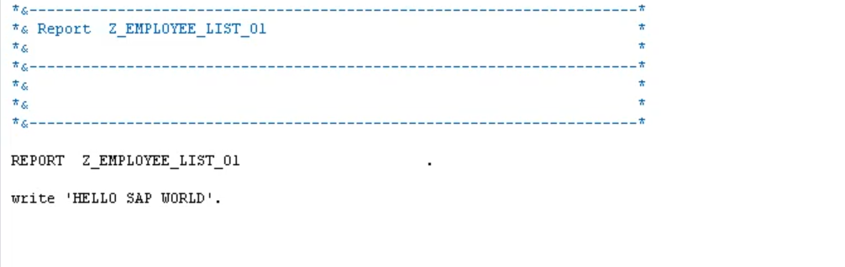

The next line of code that we see starts with a word report. And this is called a statement. And a report statement is always the first statements in any executable program we create. The statement itself is then followed by the program name that we created. Then the statement line is terminated with a full stop.

It is important to note is that every statement in ABAP must finish with the full stop or period.